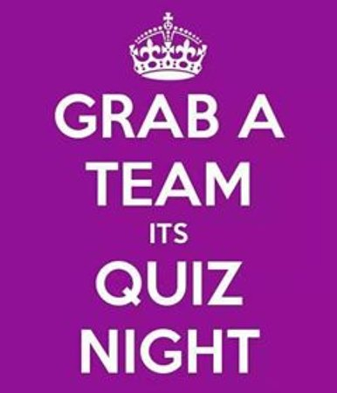

ANNUAL VILLAGE LANES QUIZ
Teams of four substitutions allowed.
Please contact your lanes captain to join team. Or just come and Watch the fun.
The Lanes 626780 Yvette Wellard
Front Street 626716 Jackie Parker
Back lane 626462 Gill Powell
Dark lane & Cross Lane 626312 Vicky Appleby
FUN NIGHT. FREE ADDMISSION
Bring your own drinks.
Saturday 22nd February 7pm start in Village hall

